Test Case: tc003_SPX_Dev5_Crear_Requisicion_Spot_Tipo_Cobro_CC_Urgent
Step 1 - Enter username and password and click to button Enter : Credentials Entered
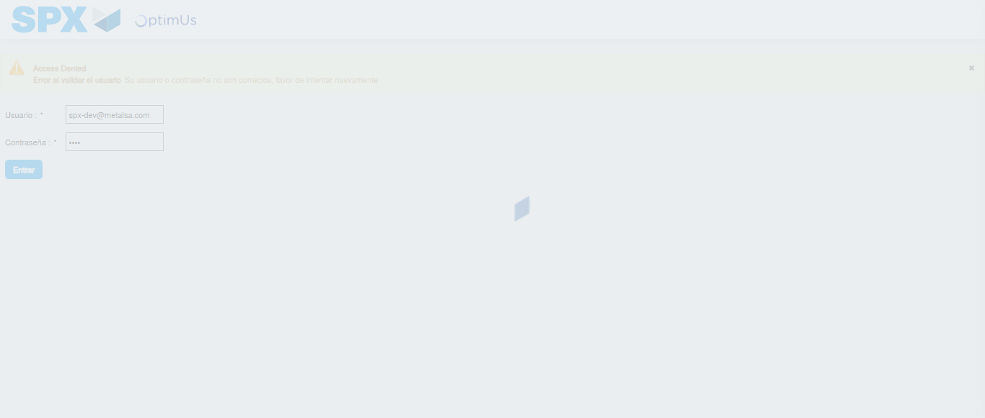Image file-name: QC_Testing-tc003_SPX_Dev5_Crear_Requisicion_Spot_Tipo_Cobro_CC_Urgent-nov. 28 2025, 10 22 47 a. m.

Step 2 - Select to UEN and Access to Spot Buy Requisitions : UEN Correctly selected and Correct access
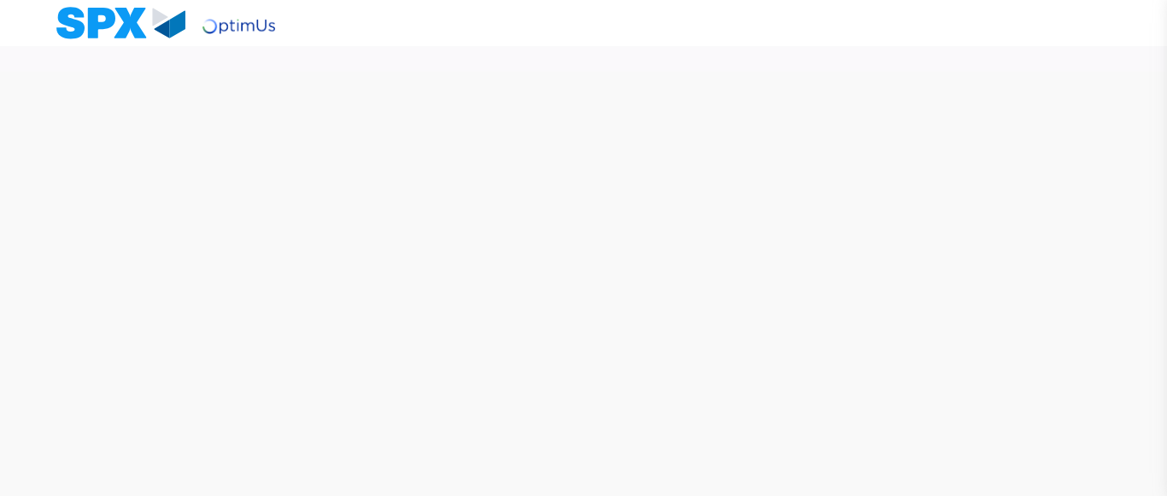Image file-name: QC_Testing-tc003_SPX_Dev5_Crear_Requisicion_Spot_Tipo_Cobro_CC_Urgent-nov. 28 2025, 10 22 51 a. m.

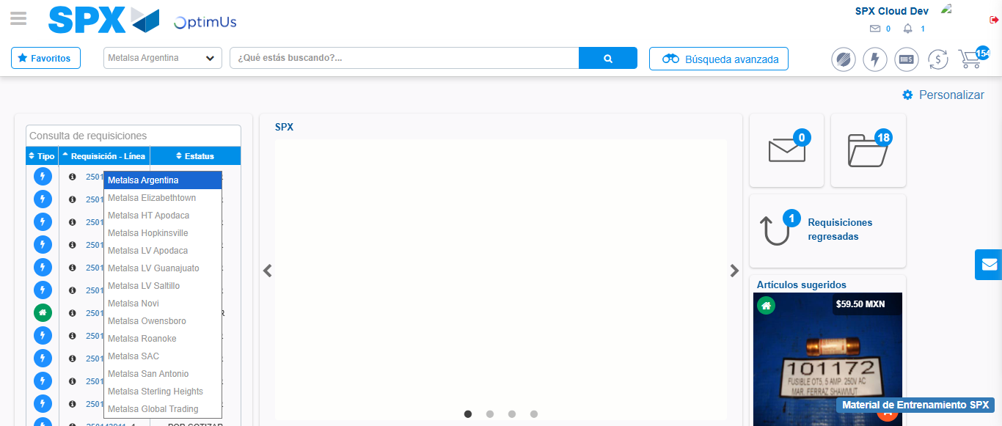Image file-name: QC_Testing-tc003_SPX_Dev5_Crear_Requisicion_Spot_Tipo_Cobro_CC_Urgent-nov. 28 2025, 10 22 52 a. m.

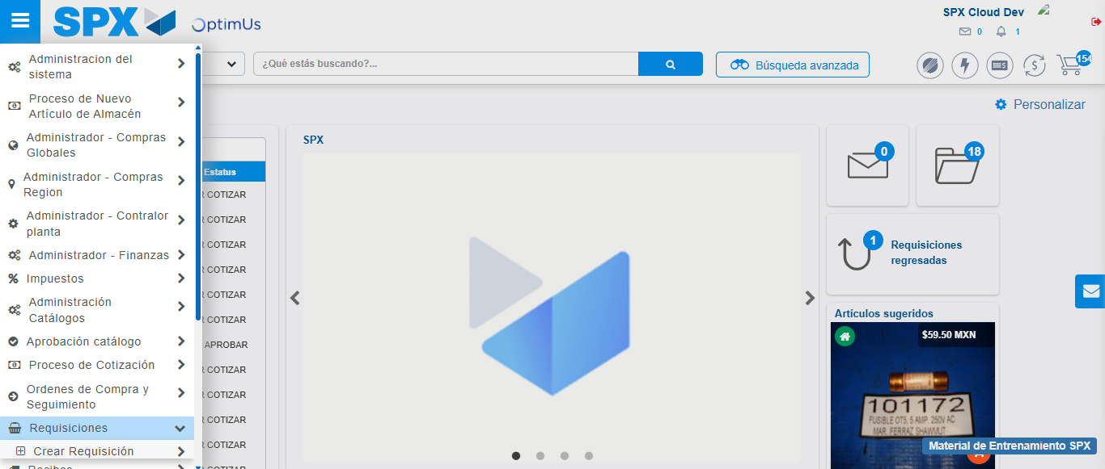Image file-name: QC_Testing-tc003_SPX_Dev5_Crear_Requisicion_Spot_Tipo_Cobro_CC_Urgent-nov. 28 2025, 10 22 53 a. m.

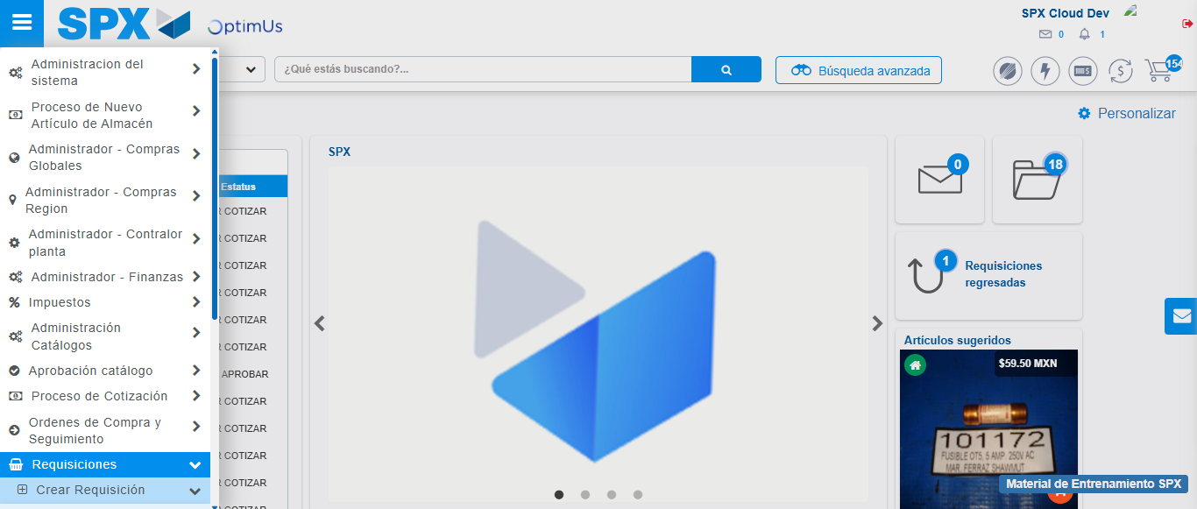Image file-name: QC_Testing-tc003_SPX_Dev5_Crear_Requisicion_Spot_Tipo_Cobro_CC_Urgent-nov. 28 2025, 10 22 54 a. m.

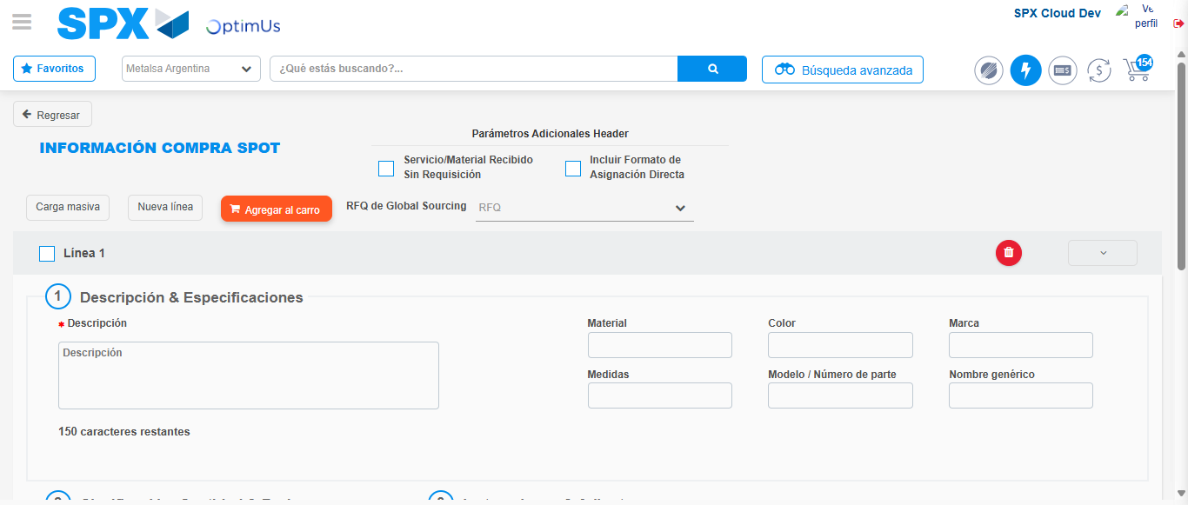Image file-name: QC_Testing-tc003_SPX_Dev5_Crear_Requisicion_Spot_Tipo_Cobro_CC_Urgent-nov. 28 2025, 10 22 58 a. m.

Step 3 - Data Capture Spot Buy Requisition: Data captured correctly
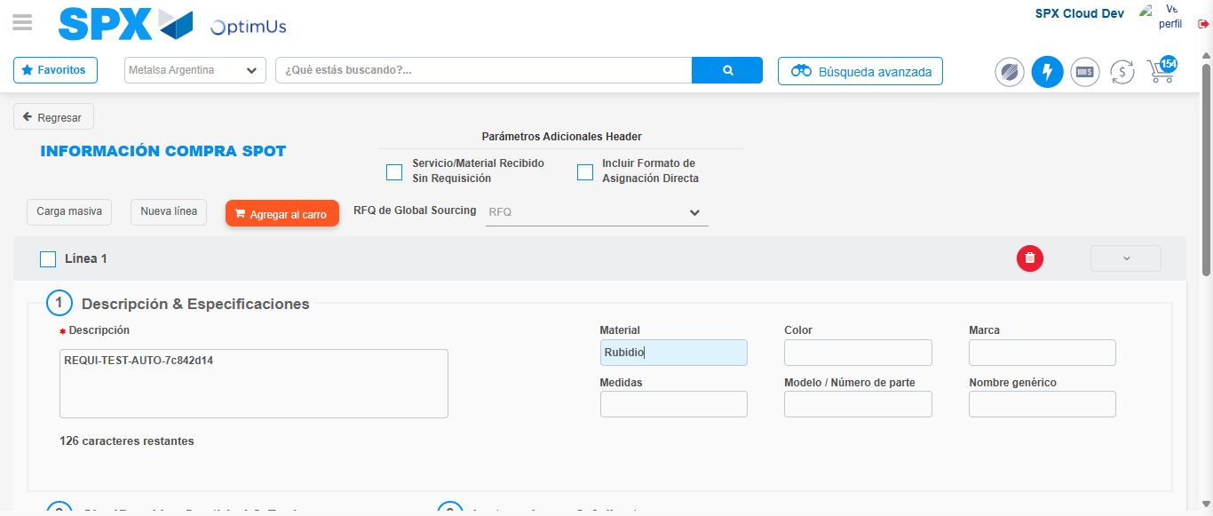Image file-name: QC_Testing-tc003_SPX_Dev5_Crear_Requisicion_Spot_Tipo_Cobro_CC_Urgent-nov. 28 2025, 10 22 59 a. m.

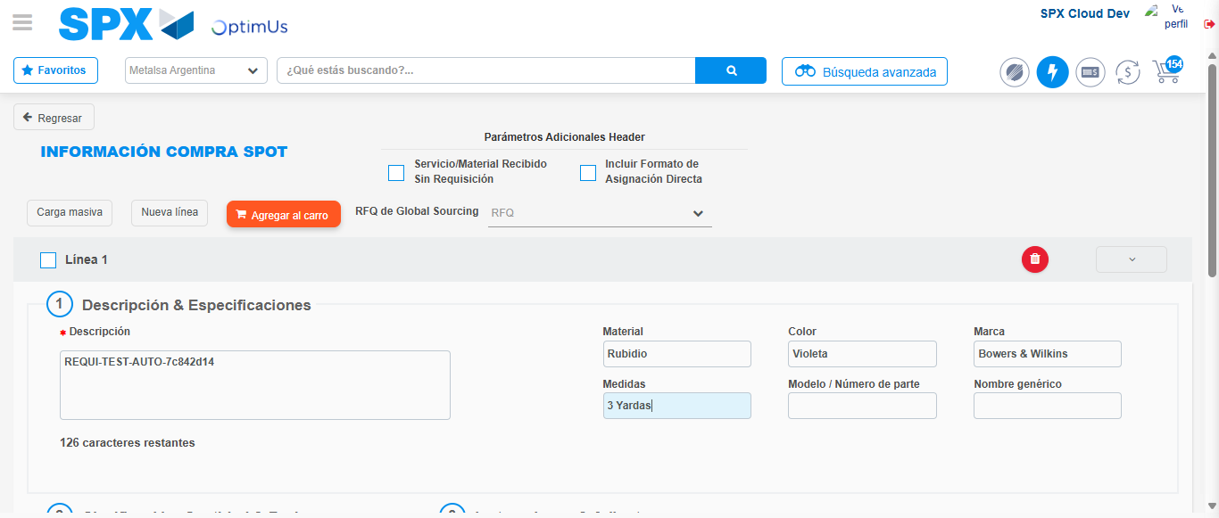Image file-name: QC_Testing-tc003_SPX_Dev5_Crear_Requisicion_Spot_Tipo_Cobro_CC_Urgent-nov. 28 2025, 10 23 00 a. m.

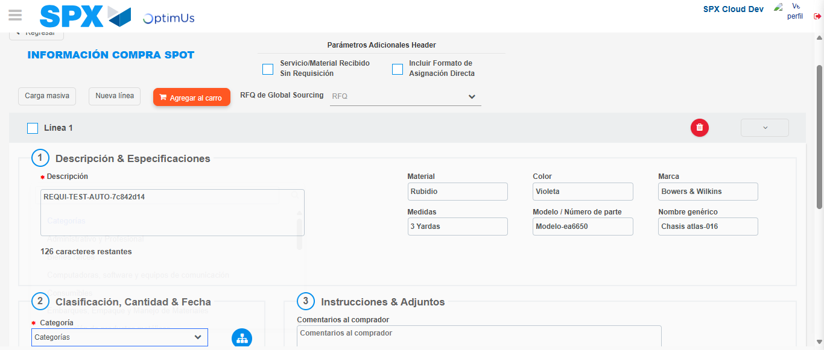Image file-name: QC_Testing-tc003_SPX_Dev5_Crear_Requisicion_Spot_Tipo_Cobro_CC_Urgent-nov. 28 2025, 10 23 01 a. m.

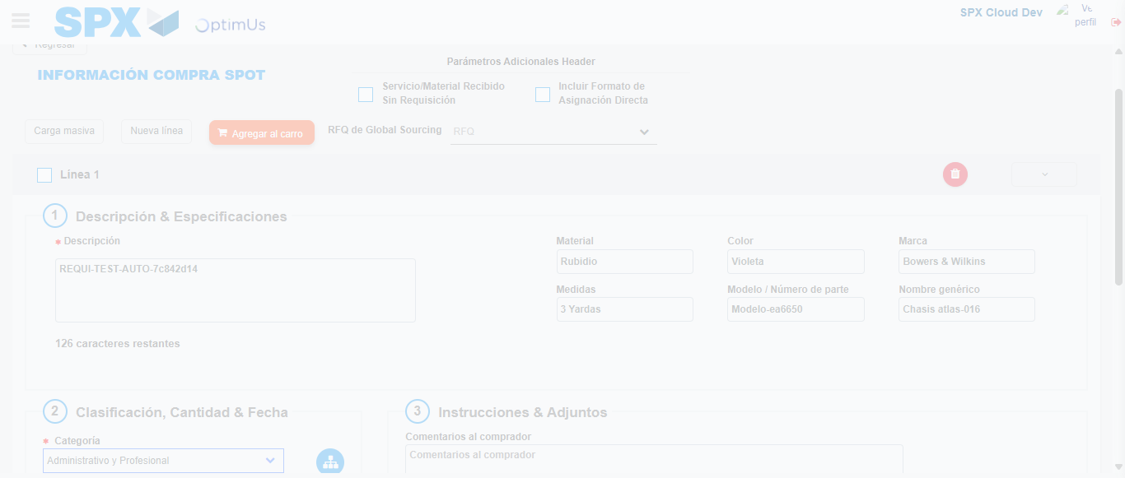Image file-name: QC_Testing-tc003_SPX_Dev5_Crear_Requisicion_Spot_Tipo_Cobro_CC_Urgent-nov. 28 2025, 10 23 02 a. m.

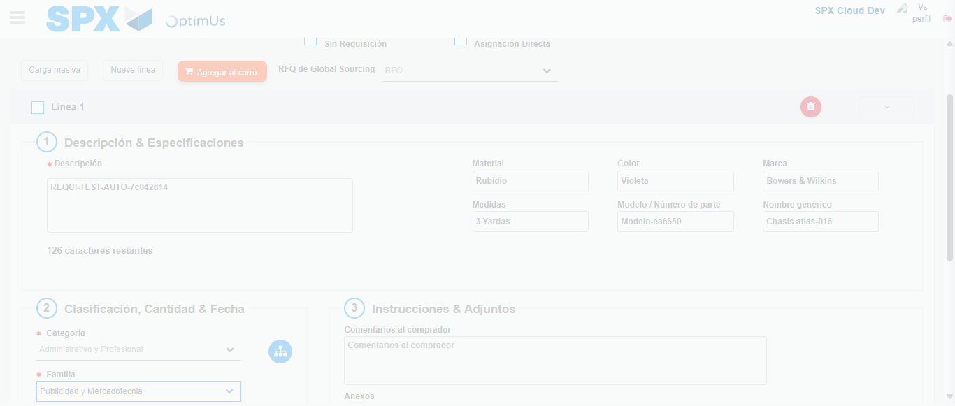Image file-name: QC_Testing-tc003_SPX_Dev5_Crear_Requisicion_Spot_Tipo_Cobro_CC_Urgent-nov. 28 2025, 10 23 04 a. m.

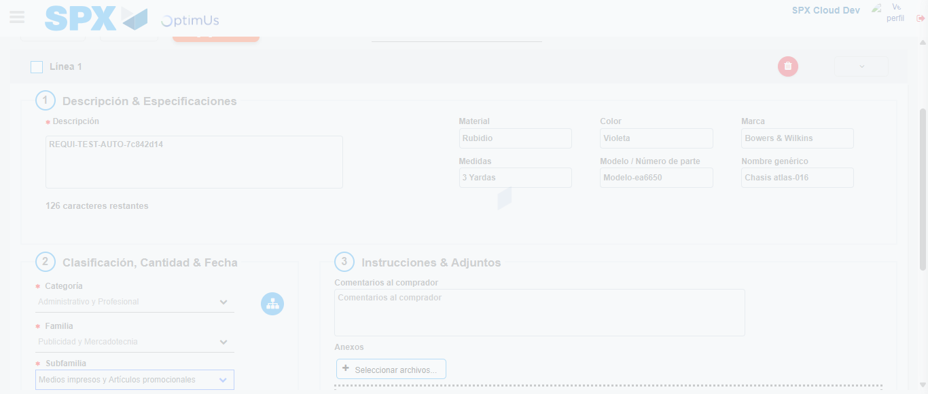Image file-name: QC_Testing-tc003_SPX_Dev5_Crear_Requisicion_Spot_Tipo_Cobro_CC_Urgent-nov. 28 2025, 10 23 05 a. m.

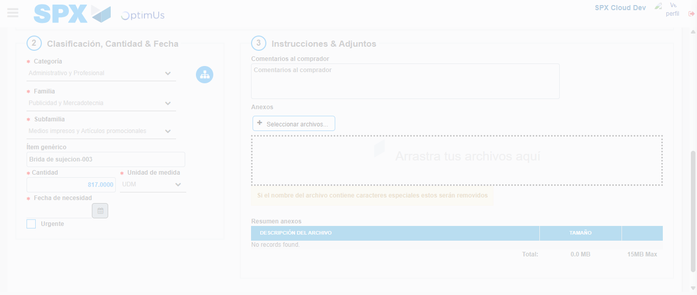Image file-name: QC_Testing-tc003_SPX_Dev5_Crear_Requisicion_Spot_Tipo_Cobro_CC_Urgent-nov. 28 2025, 10 23 06 a. m.

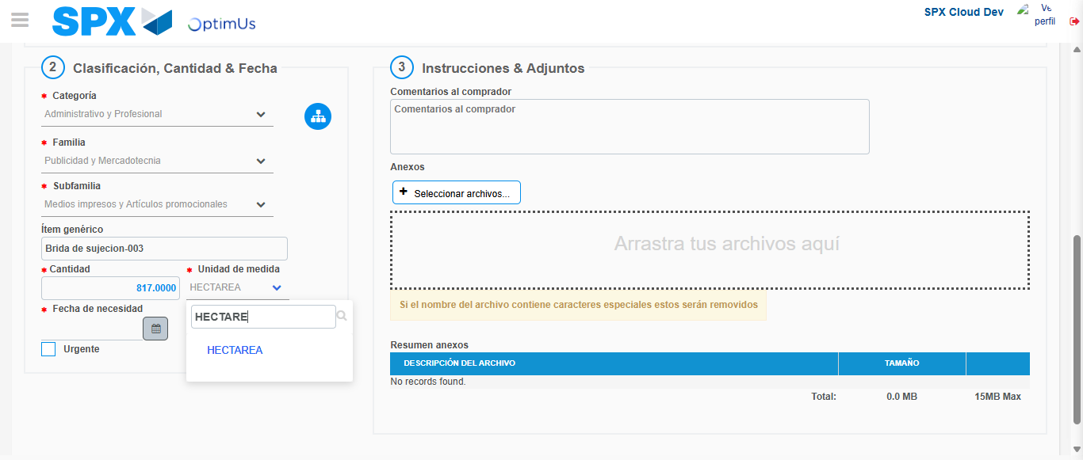Image file-name: QC_Testing-tc003_SPX_Dev5_Crear_Requisicion_Spot_Tipo_Cobro_CC_Urgent-nov. 28 2025, 10 23 07 a. m.

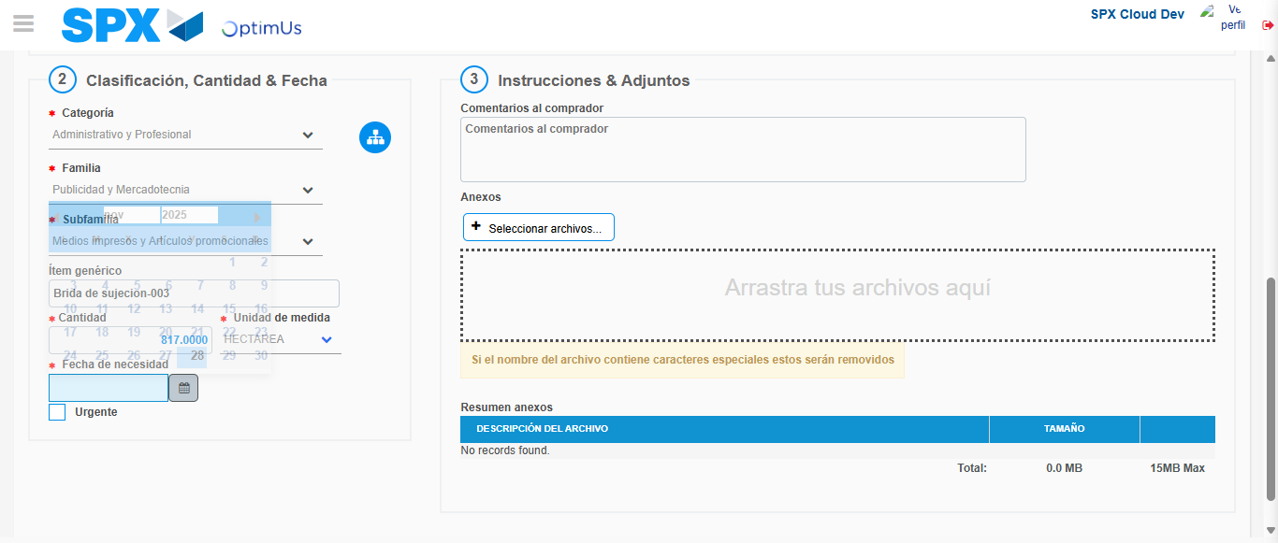Image file-name: QC_Testing-tc003_SPX_Dev5_Crear_Requisicion_Spot_Tipo_Cobro_CC_Urgent-nov. 28 2025, 10 23 08 a. m.

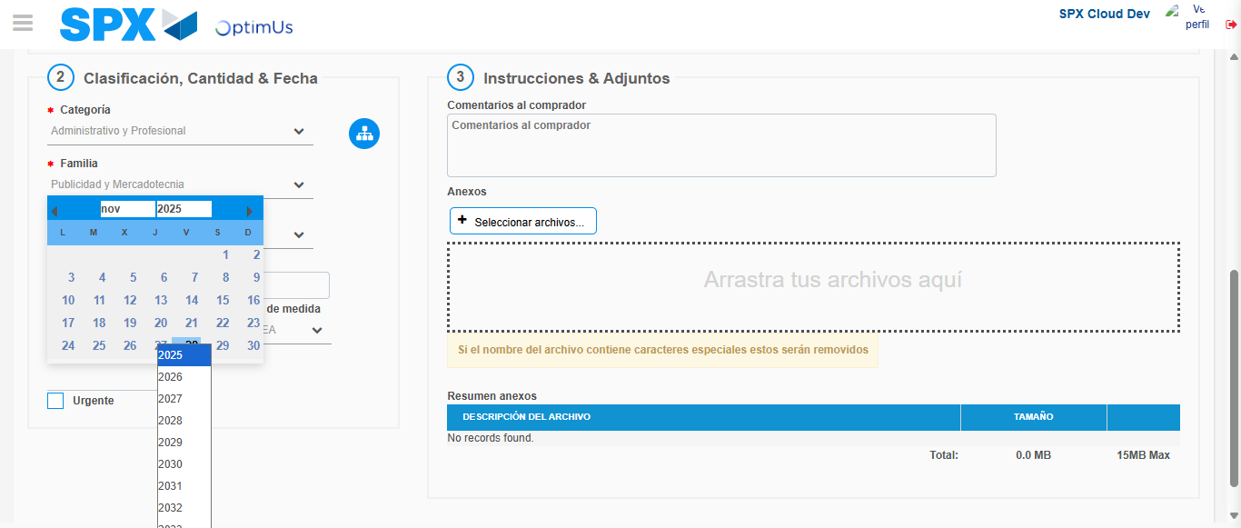Image file-name: QC_Testing-tc003_SPX_Dev5_Crear_Requisicion_Spot_Tipo_Cobro_CC_Urgent-nov. 28 2025, 10 23 09 a. m.

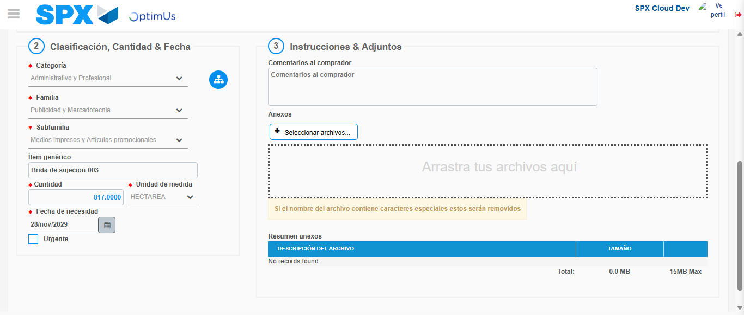Image file-name: QC_Testing-tc003_SPX_Dev5_Crear_Requisicion_Spot_Tipo_Cobro_CC_Urgent-nov. 28 2025, 10 23 10 a. m.

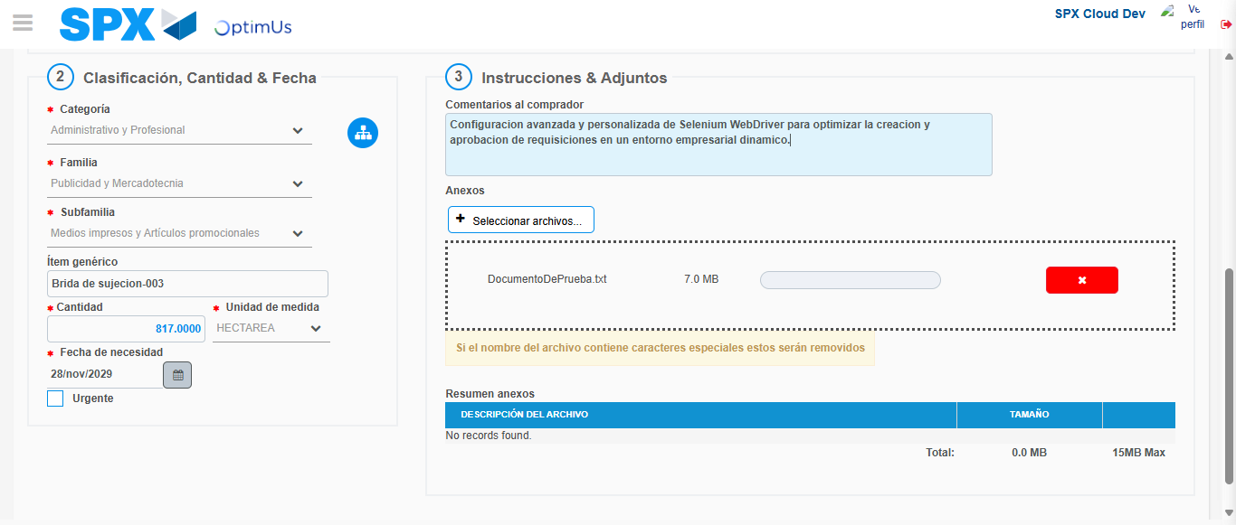Image file-name: QC_Testing-tc003_SPX_Dev5_Crear_Requisicion_Spot_Tipo_Cobro_CC_Urgent-nov. 28 2025, 10 23 11 a. m.

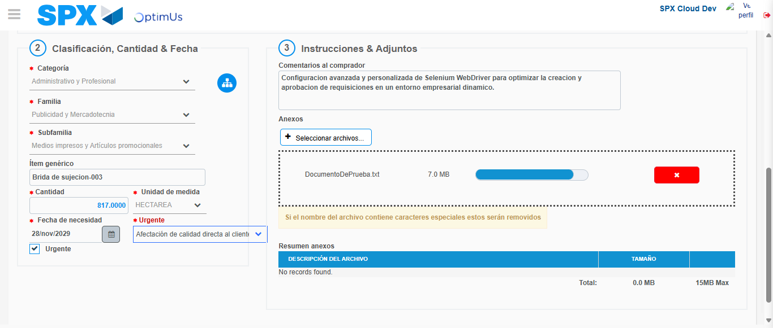Image file-name: QC_Testing-tc003_SPX_Dev5_Crear_Requisicion_Spot_Tipo_Cobro_CC_Urgent-nov. 28 2025, 10 23 12 a. m.

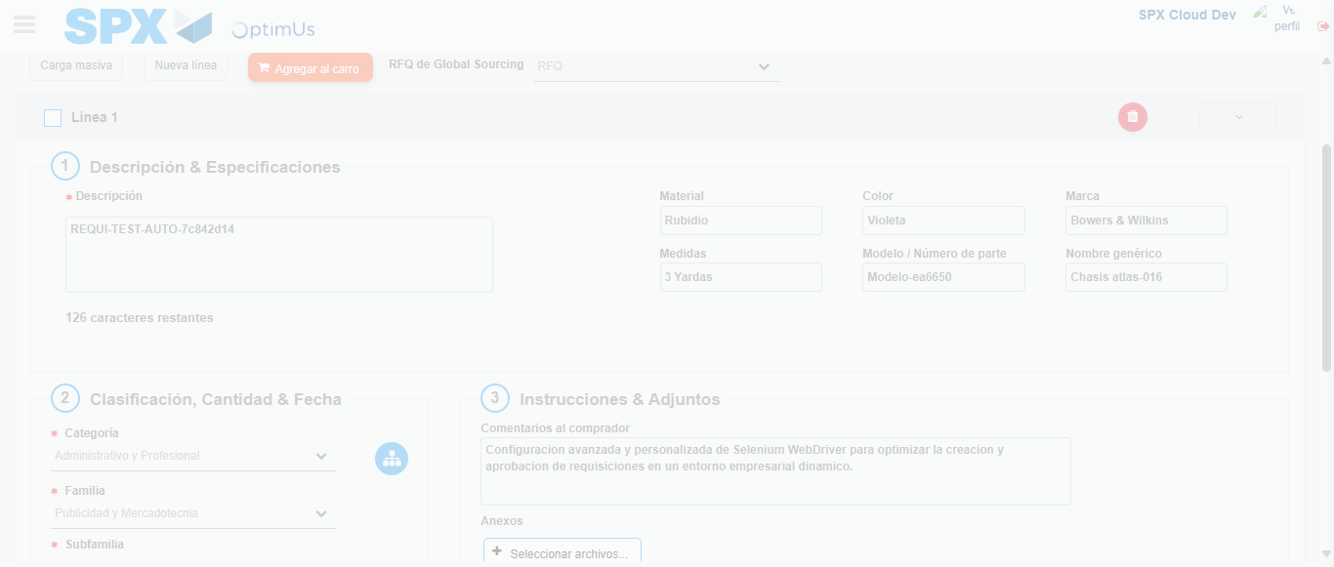Image file-name: QC_Testing-tc003_SPX_Dev5_Crear_Requisicion_Spot_Tipo_Cobro_CC_Urgent-nov. 28 2025, 10 23 16 a. m.

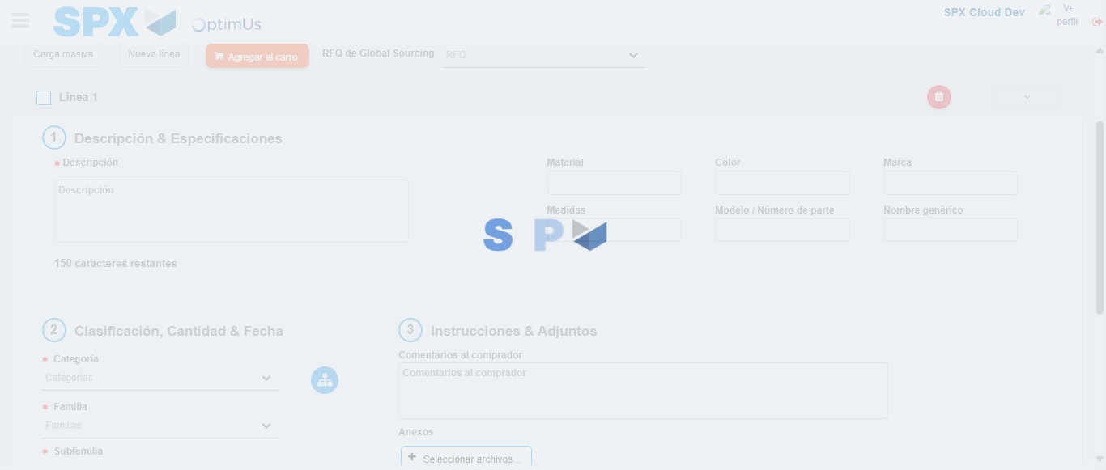Image file-name: QC_Testing-tc003_SPX_Dev5_Crear_Requisicion_Spot_Tipo_Cobro_CC_Urgent-nov. 28 2025, 10 23 18 a. m.

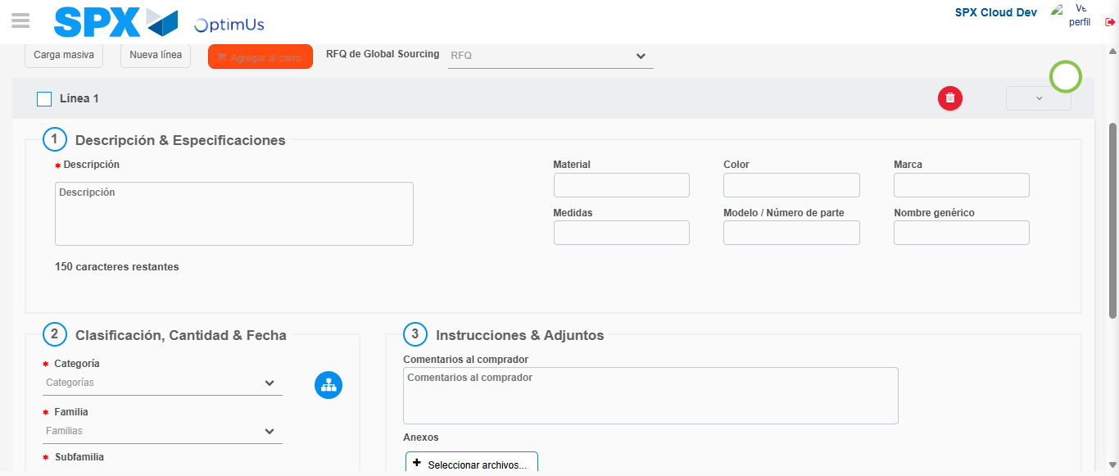Image file-name: QC_Testing-tc003_SPX_Dev5_Crear_Requisicion_Spot_Tipo_Cobro_CC_Urgent-nov. 28 2025, 10 23 19 a. m.

Step 4 - Select to Requisition: Requisition Correctly selected
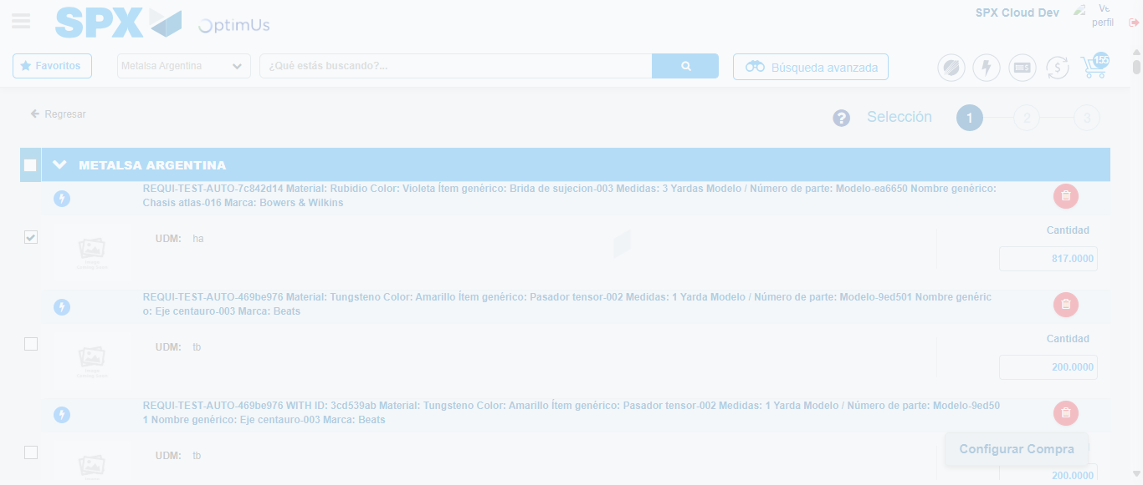Image file-name: QC_Testing-tc003_SPX_Dev5_Crear_Requisicion_Spot_Tipo_Cobro_CC_Urgent-nov. 28 2025, 10 23 29 a. m.

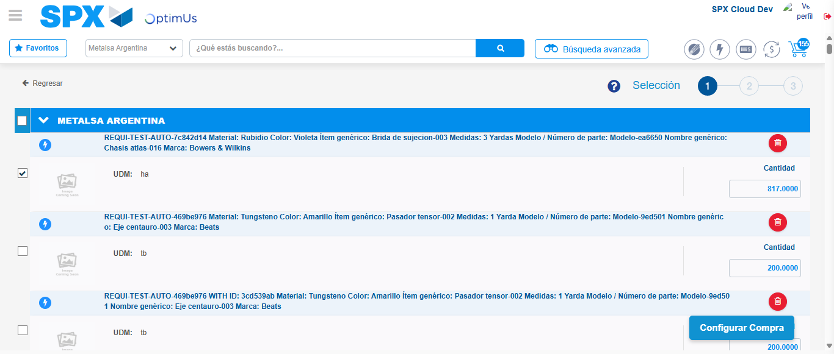Image file-name: QC_Testing-tc003_SPX_Dev5_Crear_Requisicion_Spot_Tipo_Cobro_CC_Urgent-nov. 28 2025, 10 23 32 a. m.

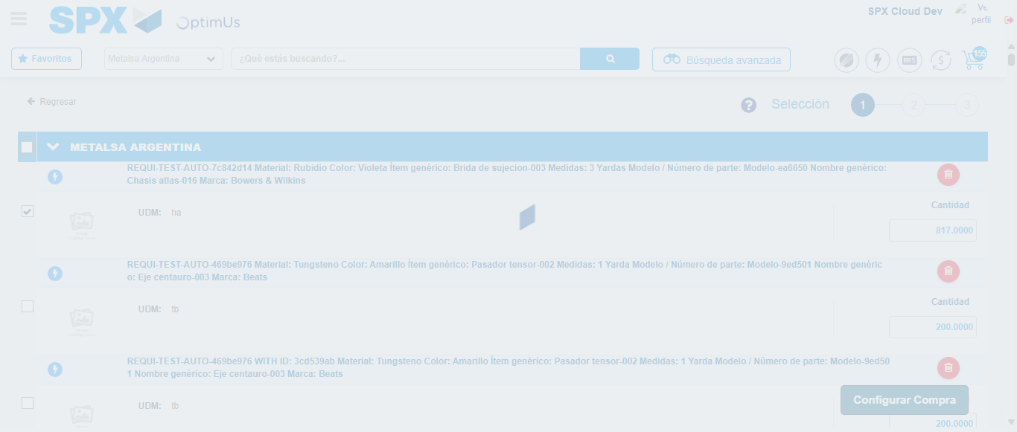Image file-name: QC_Testing-tc003_SPX_Dev5_Crear_Requisicion_Spot_Tipo_Cobro_CC_Urgent-nov. 28 2025, 10 23 33 a. m.

Step 5 - Select Type Account For Requisition: Type Account Correctly selected
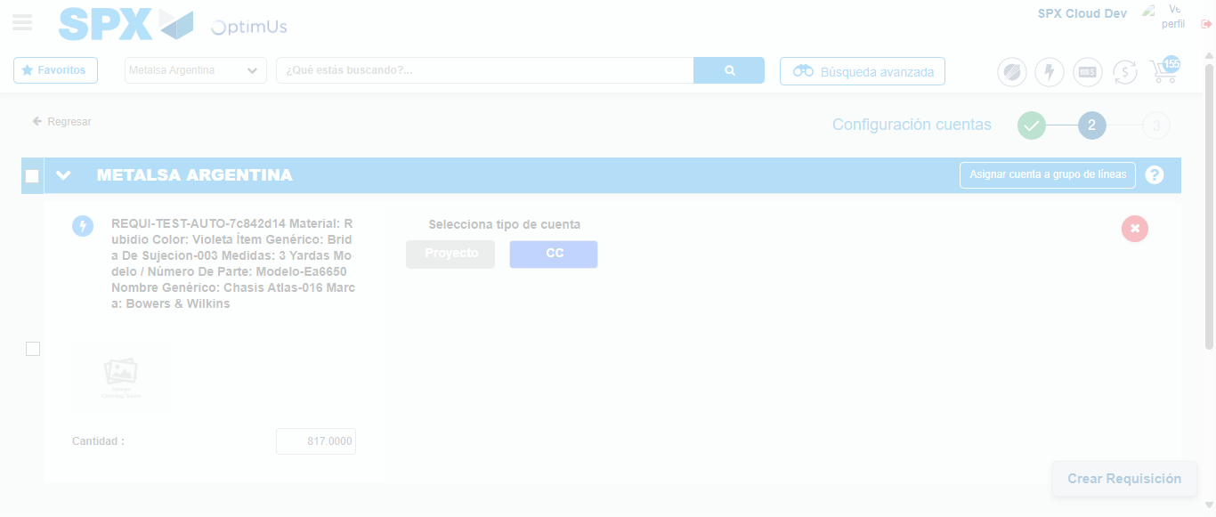Image file-name: QC_Testing-tc003_SPX_Dev5_Crear_Requisicion_Spot_Tipo_Cobro_CC_Urgent-nov. 28 2025, 10 23 36 a. m.

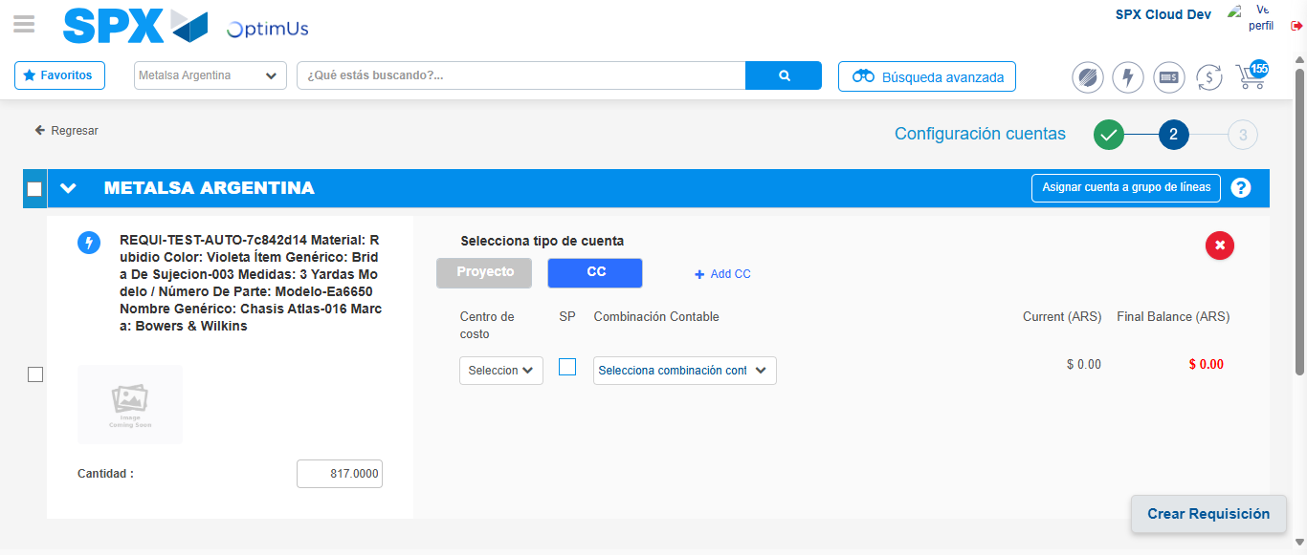Image file-name: QC_Testing-tc003_SPX_Dev5_Crear_Requisicion_Spot_Tipo_Cobro_CC_Urgent-nov. 28 2025, 10 23 40 a. m.

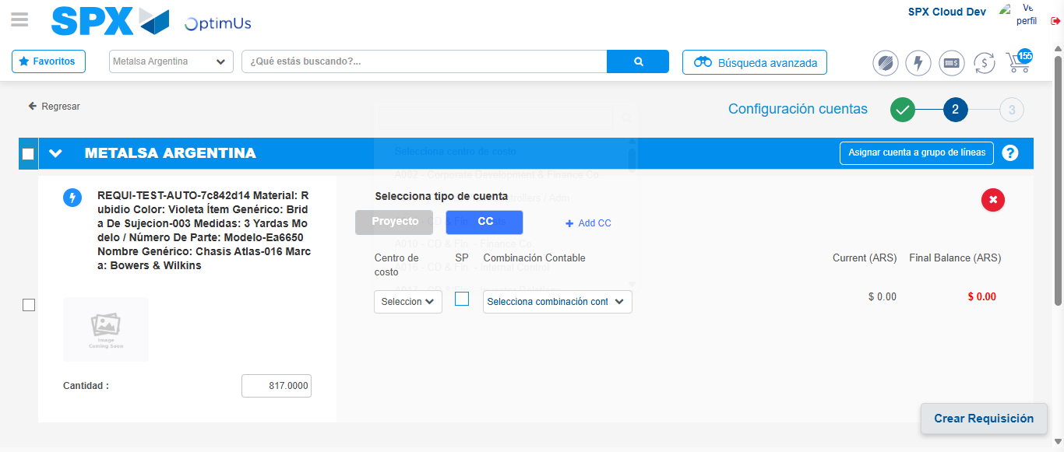Image file-name: QC_Testing-tc003_SPX_Dev5_Crear_Requisicion_Spot_Tipo_Cobro_CC_Urgent-nov. 28 2025, 10 23 43 a. m.

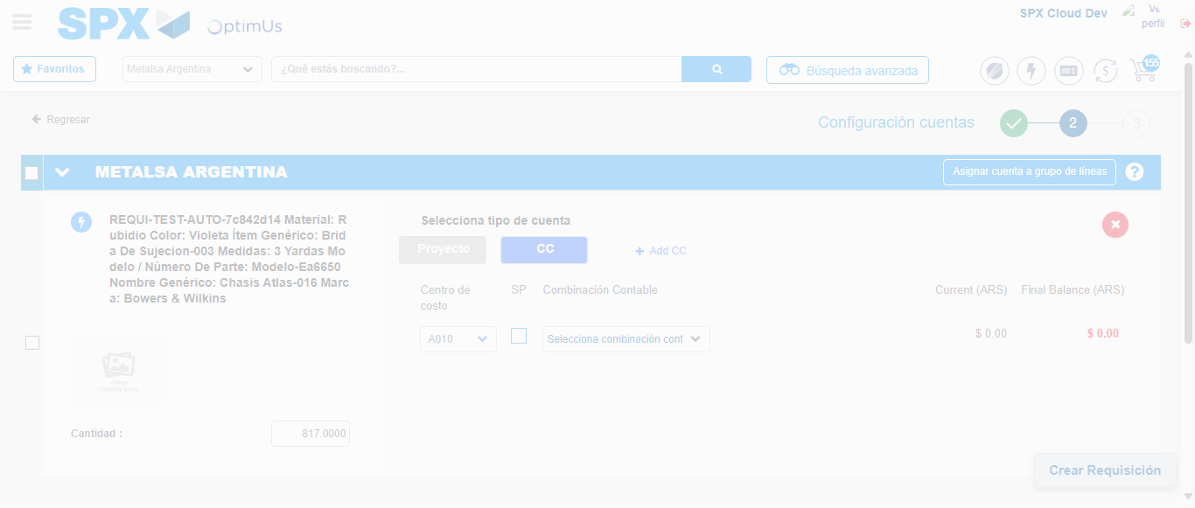Image file-name: QC_Testing-tc003_SPX_Dev5_Crear_Requisicion_Spot_Tipo_Cobro_CC_Urgent-nov. 28 2025, 10 23 44 a. m.

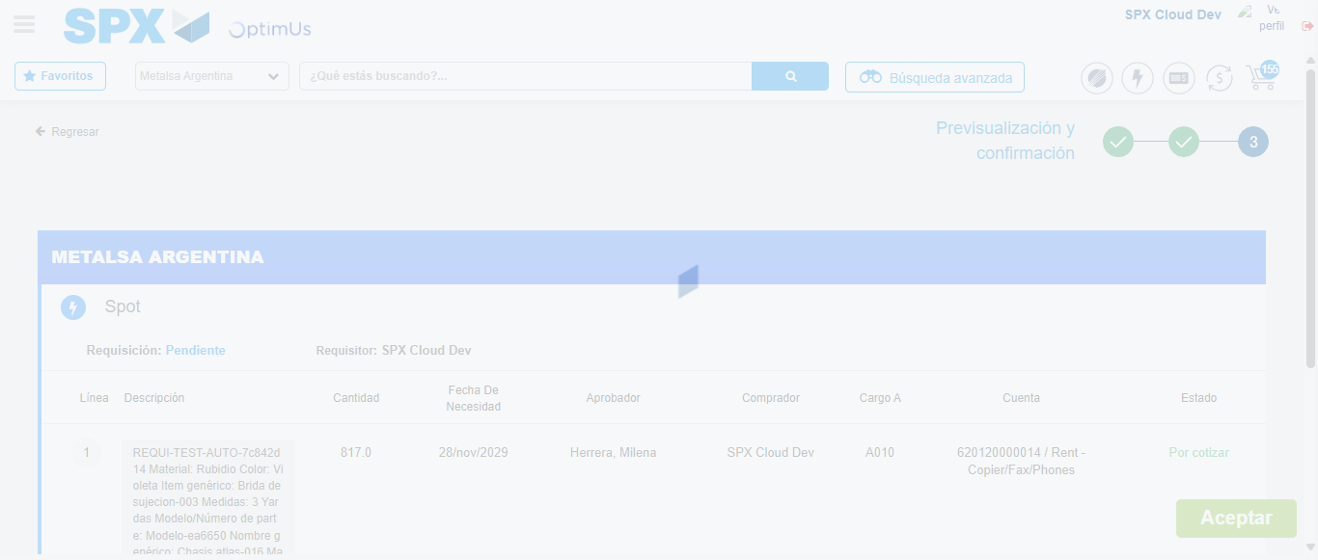Image file-name: QC_Testing-tc003_SPX_Dev5_Crear_Requisicion_Spot_Tipo_Cobro_CC_Urgent-nov. 28 2025, 10 23 47 a. m.

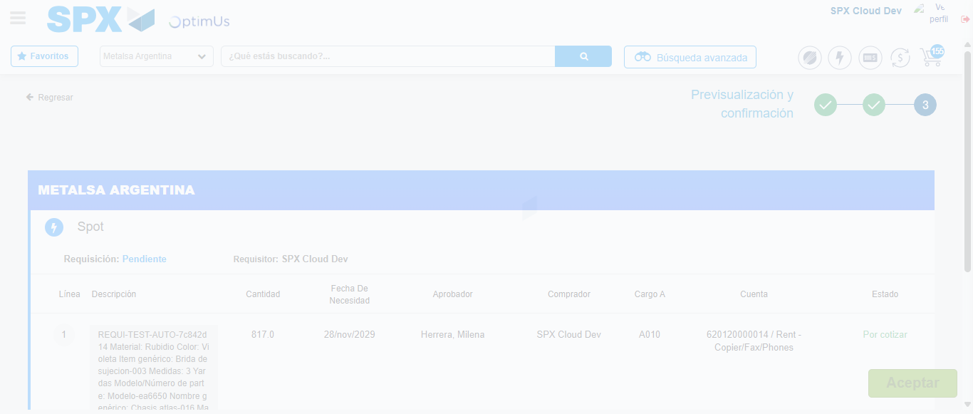Image file-name: QC_Testing-tc003_SPX_Dev5_Crear_Requisicion_Spot_Tipo_Cobro_CC_Urgent-nov. 28 2025, 10 23 51 a. m.

Step 6 - Accept to Requisition: Requisition Accepted
Image file-name: QC_Testing-tc003_SPX_Dev5_Crear_Requisicion_Spot_Tipo_Cobro_CC_Urgent-nov. 28 2025, 10 23 51 a. m.

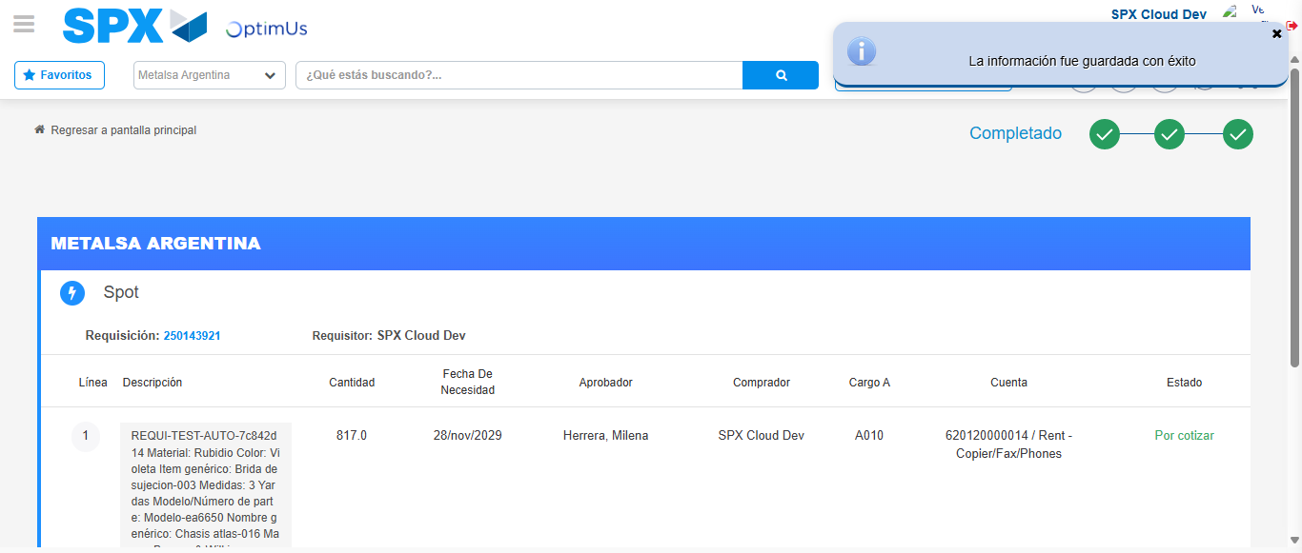Image file-name: QC_Testing-tc003_SPX_Dev5_Crear_Requisicion_Spot_Tipo_Cobro_CC_Urgent-nov. 28 2025, 10 23 55 a. m.

